***Organisational   
Studies and Innovation Review***

*Vol. x, no.x, summer, 201x*

**Insert title of the paper here in size 14, Times New Roman (TNR), bold, centred**

Author Name 1*, Author Name 2** and Author Name 3**

*Affiliation\**

*Affiliation\*\**

*Affiliation\*\*\**

**Abstract**: your abstract should start here. Not in the following line. It should be in Times New Roman, size 12. It should not be more than 200 words and it should include purpose/relevance, methodology, main findings and originality/contributions/implications. Regarding keywords, these should be relevant to the written article and should be maximum of 6. As shown below, keywords should be provided in italics and in the same row separated by commas.

**Keywords:** *OSIR, guidelines, template, examples.*

# Introduction

The present document will be used to exemplify and give guidelines for submission of papers in the Journal of Organisational Studies and Innovation (OSIR) from February 2016 onwards.

Papers that do not follow these guidelines will not be published so please read carefully this document.

Please note that this publication accepts papers written in English (UK) only.

There is no space between headings and the main body of text. Also, use single spacing throughout your document and note that headings are not numbered.

Also remember that in order to submit your article online, you will need to register as an Author at [www.mbacademy.co.uk/journal](http://www.mbacademy.co.uk/journal).

# Literature Review

Fist level headings should be as shown above in Times New Roman, size 14, bold.

Second level headings should be Times New Roman, size 12, bold as shown below.

And third level headings should be Times New Roman, size 12, italics.

## Second level Headings (TNR, size 12, bold): Authors Guidelines

Journal of Organisational Studies and Innovation welcomes the submissions of scholarly articles, and research papers. Papers submitted to the OSIR must be original, not published previously or under consideration for publication elsewhere.

OSIR is committed to the editorial principles laid down by the Committee on Public Ethics.

## Manuscript Guidelines

Submission of your article is via the website and will consist of two documents: a title page (use the template) and the article itself. The article should be no longer than 6,000 words excluding references. The articles should be submitted without any indication of its authorship or page numbers. A separate document should be submitted which has the title of the article, names of the authors with affiliation and contact details and the biographical details of the authors.

It is essential that authors should have their work proofread by a third party and, if the author is not a native English speaker, that it is proofread by a native English speaker. OSIR expects grammar and spelling to be faultless and articles will be rejected if they are not, even if the work fulfils the other requirements.

Authors must comply with the following guidelines before their work will be considered and articles not in compliance will be returned to the author.

We Follow Harvard Referencing System, please follow the instructions provided in the Harvard Ref PDF guidelines.

## Structure of the Paper

You should submit two separate documents:

1. Title page:

Containing the title of the paper, author contact information, and a short auto-biography for each author

1. Full paper including:

Title

Abstract

Keywords

Introduction

Body of paper

Tables, figures and diagrams/equations (placed where they belong)

Conclusion

Acknowledgments (if applicable)

References (Harvard Ref System)

Appendices (if applicable)

Each of these headings is further detailed next.

### Third level headings (TNR, size 12, italics): Title Page

The title page should contain the paper title and each author name, affiliation, mailing address, and email address with the contact author indicated. The title page should also contain a short auto-biography of no more than 100 words for each author. Note the formatting guidelines below:

* Author names (12pt Time Roman, No “Dr”, “PhD” or any other title)
* University Name, Country (11pt Time Roman). Department and email address, please.

### Full paper elements

### Title

The title should be 14pt Times New Roman, Title Case, Bold, Align text to the left. It should be concise, descriptive, and contain the keywords or key phrases. Search engines assume that the title contains all of the important words that describe the topic of the paper. The use of acronyms should be avoided in the title and keywords unless widely recognized and understood.

### Abstract (12pt, Times New Roman)

Abstracts should not exceed 200 words. The abstract should contain all the keywords and key phrases at least once and more than once if necessary. The abstract should be one paragraph only.

### Keywords

Should follow the Abstract. List five or six Keywords maximum.

### Body Text

The text is single-spaced, uses a 12-point Times New Roman font. Employ italics, rather than underling, for emphasis. Do not use page numbering anywhere in the manuscript! Alignment should be fully justified and all margins should be set to 1 inch (2.54 cm).

As shown in this document, paragraphs should not be indented at first but should be indented afterwards (0.5 cm).

### Main Headings

Three levels of headings are allowed. The first level should be Bold 14 Time New Roman, second level Bold 12 Time New Roman, and third level Italics 12 Time New Roman.

The paper should include as main headings: introduction, literature review/theoretical background/background of the study, methodology, results and discussion, conclusions.

### Footnotes

The use of footnotes and endnotes is prohibited. Incorporate any additional material within the main text.

### Abbreviations

Abbreviations should be defined at first mention and used consistently thereafter.

### References

References should be arranged alphabetically and follow Harvard Ref System. References should not be inserted as footnotes (see Harvard Ref PDf with guidelines).

### Citations and References

* Use an author-date citation in the text. Each reference cited in the text must be listed in the reference page and each entry in the reference page must be cited in the text. If the exact words of the cited work are quoted, a page number must be included in the citation eg. Yesslen (2009, p.19) stated that the world is upside down.
* When citing more than 2 authors only the name of the first author should appear followed by “et al.” All author’s names should appear in References.
* When using a direct quotation from an author in your text, a page number is used. eg. Streeter stated that “the only possible direction is vertical and…..in this manner” (2003, p.276).
* The references section lists all the cited authors in the article alphabetically by the author’s surname. They are not numbered or indented. The references section should only contain the citations in the article.

# Methodology

In the methodology please refer to the research strategy used, sample size and instruments used. When appropriate provide a table of constructs/dimensions/indicators and respective sources of where you took the scales from.

## Tables and Figures

All illustrations, figures, and tables are placed within the text at the appropriate points rather than at the end or in a separate document. Each figure or table must be labelled with a descriptive caption and numbered sequentially (as shown as an example in Figure 1 below). All figures and tables must have a title and appear centre aligned and caption aligned with figure, Time News Roman, 10pt, Italic. Both figure and table captions should be located above the figures and tables. Use the Microsoft Word table function to create tables, not spreadsheets. All figures and tables should be of highest quality (same font labels within the figure and legible).

In figure 1, the red double headed arrows represent the five main characteristic dependent variables of the conceived framework. The blue dashed arrows indicate the interactive and spurious effects of one element on another.

Figure 1: Conceptual Model



(Source: Author surname, year, page number)

Figure 2: Conceptual Model



(Source: Ramasesh and Browning, 2014, p.192)

# Results and Discussion

This section should describe and discuss main findings of the research conducted. All tables and figures included should be mentioned within text and thoroughly explained. Please note that tables should be provided as shown below with top and bottom borders only (no colours should be used).

Figure 2 shows that…

Fig 2: Plot of simulation results without TE influence on PT

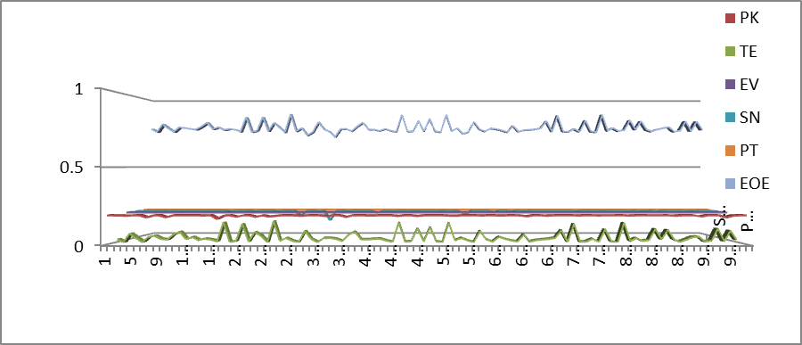

As summarized in table 1, (…)

Table 1: Sample demographics.

|  |  |
| --- | --- |
| Variable | Percentage |
| **Gender**  Male  Female | 42%  58% |
| **Age**  18-27  28-37  38-47  48-57  Over 57 | 30%  10%  20%  22%  18% |

Equations should be shown when used within text as shown below.

Initial probability of Technology contribution is given as

*P(TEi) = P(TE|Inn,Inv,Init,Research)……… eq(1)*

Probabilistic value of Technology given the influence of Education is defined as

*P(TE)= P(TEi)+P(Ed)…………eq(2)*

Please note that tables copied directly from SPSS or any other statistical packages will not be permitted due to copyright regulations. Create or own tables with the relevant statistical data as shown in the example below.

Table 2: Moderation effect (example).

|  |  |  |  |
| --- | --- | --- | --- |
| *Variable* | *Model 1* | *Model 2* | *Model 3* |
| Contact  PAL  Org. size  PAL x Org. size  R-Sq  R2 Change  F-Statistics | 2.285**  -.434**  .189 | 2.172**  -.441**  -.085*  .196  .007  21.186** | .083  -1.150**  -.104  .732**  .232  .036  17.443** |

# Conclusion

This section should conclude your paper providing also limitations and suggestion for further/future research (these can be used as headings when appropriate). Theoretical, methodological and managerial implications should also be included.

# References

Bird, B., Schjoedt, L. & Baum, J.R., (2012). Editor’s Introduction. Entrepreneurs' Behavior: Elucidation and Measurement. *Entrepreneurship Theory and Practice*, 36(5), pp.889–913.

Corbett, A.C., (2007). Learning asymmetries and the discovery of entrepreneurial opportunities. *Journal of Business Venturing*, 22(1), pp.97–118.

Elmuti, D., Khoury, G. & Abdul-Rahim, B., (2011). Entrepreneur’S Personality, Education and Venture Effectiveness: Perceptions of Palestinian Entrepreneurs. *Journal of Developmental Entrepreneurship*, 16(02), pp.251–268.

Marvel, M.R. & Droege, S., (2010). Prior tacit knowledge and first-year sales: learning from technology entrepreneurs. *Journal of Small Business and Enterprise Development*, 17(1), pp.32–44.

Nazarian, A. (2014). *How to use your brain*. Basingstoke: Palgrave.